Week 6
Module 10

Prb4:
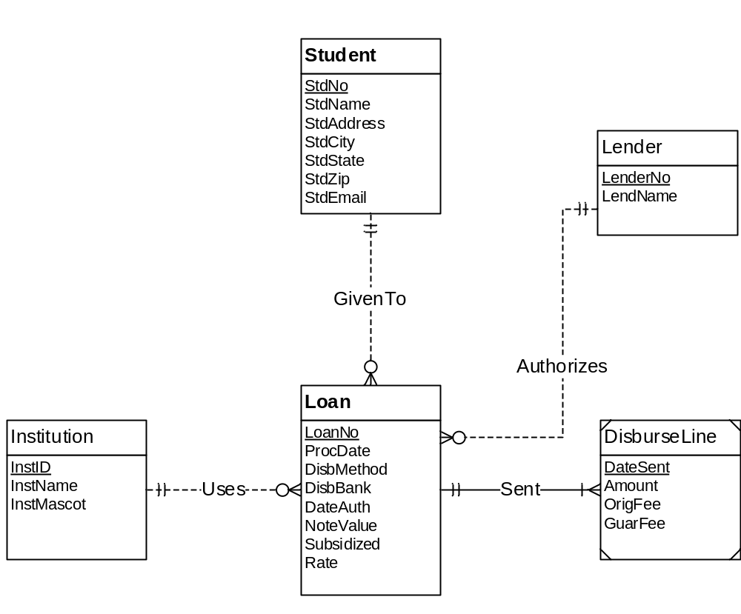

Student (StdNo, StdName, StdAddress, StdCity, StdState, StdZip, StdEmail)
Institution (InstID, InstName, InstMascot)
Loan (LoanNo, ProcDate, DisbMethod, DisbBank, DateAuth, NoteValue, Subsidized, Rate, StdNo, InstNo, LenderNo)
FOREIGN KEY(StdNo) REFERENCES Student
FOREIGN KEY(InstNo) REFERENCES Institution
FOREIGN KEY(LenderNo) REFERENCES Lender
StdNo NOT NULL
InstNo NOT NULL
LenderNo NOT NULL
Lender (LenderNo, LendName)
DisburseLine (LoanNo, DateSent, Amount, OriFee, GuarFee)
FOREIGN KEY(LoanNo) REFERENCES Loan

Note : Because of Identifying Relationship, DisburseLine primary key will be this tuple (LoanNo, DateSent),
And LoanNo NOT NULL is not needed here because it’s a primary key.

